Visit Mayor and councilors of the municipality of Noord Oost Polder

On 26 October 2021 the Mayor and councilors of the municipality of Noord Oost Polder visited NLR and DNW. During a presentation they were informed by NLR’s CFO Mr. L. Esselman about the NLR strategy 2022-2025 and Division Manager Collin Beers updated them on the industry/growing fund after which a visit to the NLR facility and the DNW wind tunnel LLF was scheduled.

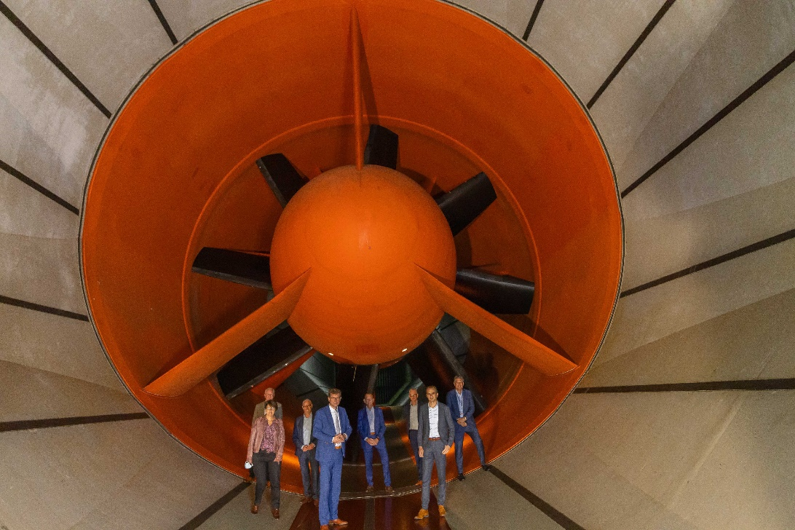

From left to right:

* Roger Thomas de Groot (Roger) Burgemeester
* Wiemer Haagsma, wethouder
* Marian Uitdewilligen
* Anjo Simonse
* Hans Wijnants wethouder
* Jacob Korterink